

What We Offer

**Community** Service

**Teamwork**

**Competition and Awards**

**Leadership**

**Scholarships**

**Travel**

**Communication Skills**

**Resume Building**

**Networking**

**Fun!**

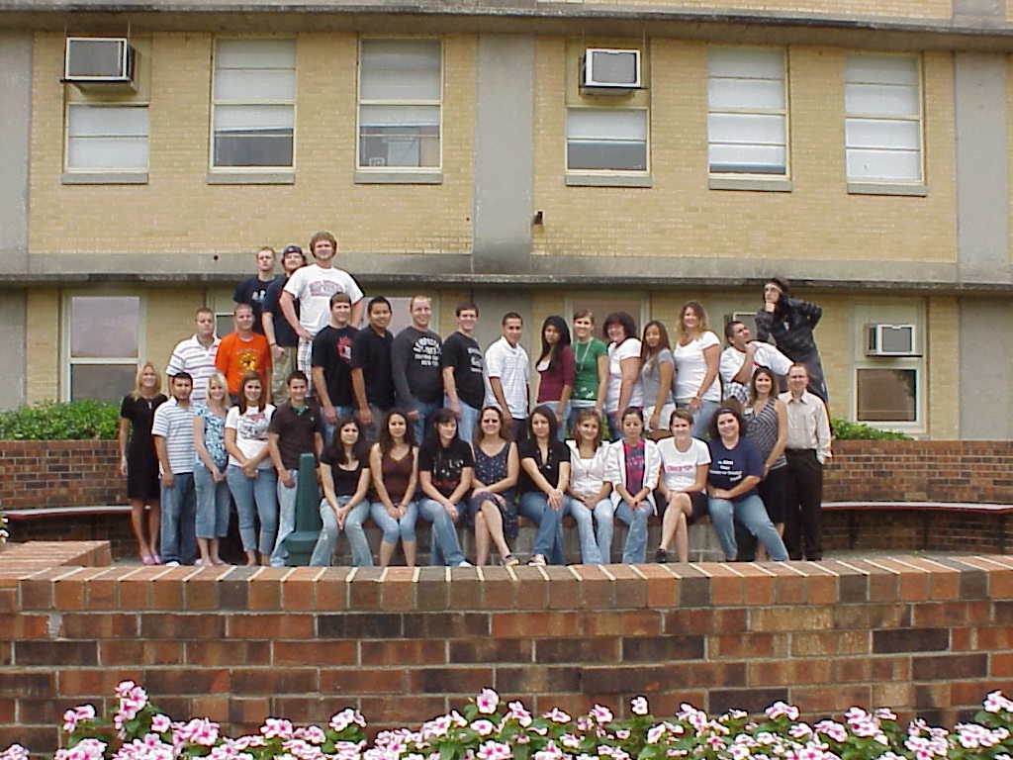

**What is Phi Beta Lambda?**

PBL isn’t just another student group — it gives you the competitive edge through team work, self-improvement, and community service opportunities. As a member of PBL, you’ll build your resume, meet business leaders in your community and beyond, experience the rewards of volunteerism, and enjoy travel and special activities.



5432 Any Street West

Townsville, State 54321

425.555.0132 ph

425.555.0133 fax

www.adatum.com.

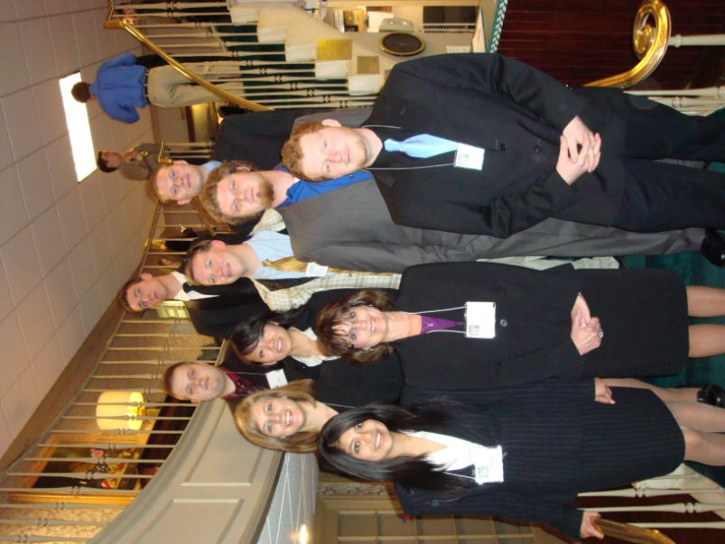

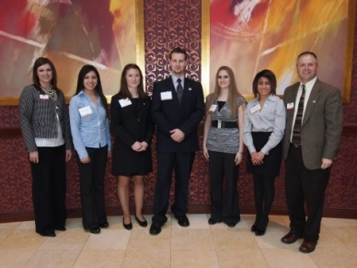

How do I Join?

Any Crowder College student may join PBL and can benefit from the experience.

To become part of the PBL organization, enroll today in:

**BSAD 110**

*Leadership Development & Service Learning*

1 Credit Hour

Meets Tuesdays 2:00 Room 319

Email for information:

[chrisfenske@crowder.edu](mailto:chrisfenske@crowder.edu)

M330

**Find success through competitions and by networking with peers and business leaders!**

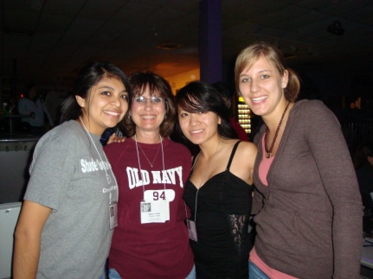

***Building a team, transforming the world, and impacting students forever.***

**Make a difference within your community while having fun and making new friends!**