Dear Applicant/Parent/Guardian,

The Crowder College Upward Bound and Upward Bound Math & Science staff would like to welcome you to the application process. The Upward Bound Programs provide services at no cost to 300 freshmen, sophomores, juniors, and seniors attending high schools in Barry, Barton, Bates, Cedar, Dade, Jasper, Lawrence, McDonald, Newton, and Vernon counties. To qualify, applicants must meet only one of two criteria. The applicant must either be a first generation college student (to be first generation, the applicant cannot reside with a natural/adoptive parent who has a Bachelor’s degree or higher), or the applicant must meet an income guideline (defined annually by the federal government). The programs’ objectives are to enhance academic motivation and help students develop the skills necessary to successfully complete high school and graduate from a program of postsecondary education.

Students participating in the program will attend three separate components. The program begins in the Academic Year when participants receive academic assistance and guidance. Other services may include: college visits, cultural and educational trips, computer literacy, academic and career assessment, ACT readiness, student success workshops, and financial aid assistance. Closer to College (C2C) sessions meet one Saturday per month. Participants from Barry, Dade, Jasper, Lawrence, McDonald, and Newton counties meet on the Neosho Crowder College campus while those in Barton, Bates, Cedar, and Vernon counties meet at the Nevada Crowder College campus. Participants work with C2C staff and instructors on the skills necessary for entering college. Participants are rewarded for academic progress and may earn up to $30 per month. Students can also earn a bonus up to $90, distributed at the end of summer, for attending all C2Cs. Parents are also provided opportunities for educational, personal, and professional enrichment. Parent courses may include financial planning, time management, coping with teens, stress management, career planning, and chemical abuse.

The next component of the program is a six-week College Prep Academy (CPA) held during the summer months. During this portion of the program, students live in the Crowder College dorms, Monday through Friday, at the Neosho campus with other Upward Bound students. They take classes that will help prepare them for their next year in school. In addition, the students spend three hours a day in a hands-on research class which is designed to help explore different career fields. The College Prep Academy also implements self-esteem and community-building activities that increase the chances of high school and college success. Students who maintain a C average during the CPA can take a week-long trip to a major city in the United States.

Once students have graduated high school, they will complete one more summer at the CPA, which is called their Bridge summer. These students enroll in up to six college credit hours at Crowder with books and tuition covered by the Upward Bound Programs. Bridge participants are provided all the privileges of the College Prep Academy.

We encourage you to apply if you wish to successfully graduate from high school and obtain a four-year college degree. Please carefully complete the entire application, paying specific attention to the checklist included in the application packet. Good luck and we hope to see you in an interview!

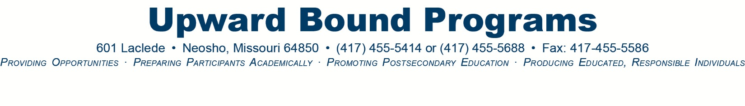
Students: Please keep this checklist for future reference.

The following application packet must be completed in its entirety for us to consider you as an applicant for the Crowder College Upward Bound or Upward Bound Math & Science program. The information requested is confidential, and we assure you that it will remain so. Anyone in the UB/UBMS office is more than happy to answer any questions you may have about the application or the program.

Qualifications

The applicant must be:
- a current freshman, sophomore, or junior.
- currently attending a high school in Barry, Barton, Bates, Cedar, Dade, Jasper, Lawrence, McDonald, Newton, or Vernon counties.
- a U.S. citizen or permanent resident.
- a potential first generation college graduate and/or satisfy an income guideline. To be first generation, the applicant cannot reside with a natural/adoptive parent who has a Bachelor’s degree. Income guidelines are predetermined by the United States Department of Education and change annually.
- able to attend 75% of Closer to College (C2C) sessions throughout the school year.
- able to attend the six-week summer residence component.
- committed to improving his/her high school grades.
- planning to attend college full-time following high school graduation

Selection Process

- Applications must be postmarked no later than Friday, September 25, 2015.
- Interviews for qualified students will be scheduled at your school after the application deadline.
- Notification of acceptance will occur by Thursday, October 21, 2015.
- Required orientations for successful applicants and their parents will be held during the last week of October. Parents, please plan to attend.

Checklist

Complete application for selection.
Complete short answer questions.
Complete financial form with student and parent/guardian signatures.
Submit recommendation form to instructor with the enclosed self-addressed envelope and make him/her aware of the September 25th deadline.
Complete two (2) transcript release forms with student and parent signatures.
Any questions may be directed to:
Crowder College Upward Bound Programs
601 Laclede Avenue
Neosho, MO 64850
(417) 455-5688 • email: upwardbound@crowder.edu

